StyleGAN (2019)

16/02/2025

Deep Leaning Course
Yael Babichenko 036737062

Shahar Rozenberg 214544991

Final Report – StyleGan (2019)

Introduction:

The paper introduces a method called ‘StyleGAN, which is a GAN architecture for the Image Generation task.
The method utilizes the already-existing ProGAN architecture and adds its own unique improvements. ProGAN is a GAN network that uses CNN to UPSAMPLE the resolution. It allows the model to learn every layer separately and ensures a more precise generation of images.

In ProGAN it is hard to monitor the whereabouts of each aspect in a generated image – and that is where StyleGAN comes to help.

The new architecture provides a couple of new improvements to help both generating better and more consistent images, as well as understanding the styles of each image.

These advancements come from methods like: Initial Mapping, Starting from Constant, AdaIN (batch normalization improvement) and Style Mixing.

The Style Mixing part utilizes the way the images are being learned (as vector) to combine 2 parts of 2 vectors (e.g. the beginning of vector w1 and the end of w2) and show what the portion of every image is when "creating" a new one.

We are very enthusiastic about this paper, as its results were groundbreaking at the time, and they also remain highly relevant today. The paper is a cornerstone evolution of AI-driven image generation, and we are glad for this opportunity to engage with it hands-on.

Implementation:

The Generator:

The Generator consists of two main components: the Mapping Network and the Synthesis Network.

The Mapping Network:

The Mapping Network transforms a latent vector z (in Z-space) into a latent vector w (in W-space), which controls the style of the generated image.
It normalizes the latent vector z (to ensure stable training) and passes it through 8 fully connected (FC) layers, each followed by a LeakyReLU activation.
The output is the latent vector w, which encodes the "style" information used to manipulate the final image’s appearance.

The Synthesis Network:

The Synthesis Network uses the latent vector w to generate high-resolution images. It starts with a learned constant tensor representing a 4x4 feature map and progressively refines it through multiple Synthesis Blocks, each corresponding to a different resolution (4x4, 8x8, 16x16, etc.).
Each Synthesis Block performs a series of operations:
- Upsampling
- Convolution (3X3 kernal)
- Noise Injection
- LeakyReLU activation
- AdaIN (Adaptive Instance Normalization).
- Conversion to RGB
As operations 2-5 are conducted twice in each block.

In AdaIN, the latent vector w is transformed using a learned affine transformation to produce style-specific scale and bias parameters.
These parameters are applied to the normalized feature maps of each block, allowing the network to adjust the style of the generated image at each resolution.
This enables the network to manipulate different aspects of the image, such as texture, structure, and fine details, in a style-controllable manner.

The to_rgb layer follows each block and converts the feature map into an RGB image.
This layer performs a 1x1 convolution to reduce the number of channels to 3 (RGB), creating an intermediate image representation.
The outputs from each block are progressively combined by upsampling and adding. This process generates increasingly detailed images, with each block adding its contribution to the result.The use of upsampling and addition ensures the generated image is high-resolution and captures fine details as it grows.

The Discriminator:

Finally, the Discriminator used in StyleGAN is a standard GAN discriminator that operates at multiple resolutions. It follows a progressive growing strategy similar to that of the Generator, processing images at different scales to match the Generator’s refinement.
This ensures both the Generator and Discriminator are trained to handle images of increasing resolution in parallel, contributing to the stable training of the model.

The Loss:

The GAN Loss Function consists of 2 main components:
The Discriminator Loss (D_loss) - which is the average binary cross-entropy between the discriminator’s output for real and fake images.
The Generator Loss (G_loss) - which is the binary cross-entropy between the discriminator’s output for fake images and the real label.

Additionally, Path Length Regularization is applied to the generator by penalizing large variations in output with respect to small changes in the latent vector, encouraging smoother and more stable image generation. This regularization is applied once every 16 batches to prevent overfitting.

Experimentation:

Limitations:

The Problem:

Normally, limitations are the last part in an experiment report. But in our case, the computation limits were a huge part of our project.
StyleGAN was trained by Nvidia on an NVIDIA DGX-1 with 8 Tesla V100 GPUs for approximately one week.
We trained using Google Colab, so we had 1 Tesla T4 GPU, that shut off every approximately 4 hours.

The main problem was that it was very hard for us to do different experiments due to these 2 facts:
- Every epoch took us ~25 minutes.
- It took Nvidia ~900 epochs to get good results.

So, we could not run our model over different parameters to see how the results change.

Our Solution:

As is known, Google Colab disconnects after the GPU ends. We solved this problem by saving our model to a shared Google Drive folder after each epoch.
In addition, we saved the global number of epochs that we have trained so far, and the G_loss and D_loss after each batch.
To utilize Google Colab to its maximum, we used 4 different users to run our model for as much time as we could.

The limitations we applied:

Beyond our inability to experiment with our will, it was still difficult to get a single epoch running.
To encounter this, we consulted with the lecturer and decided to reduce the resolution.
Due to the progressive architecture, we could stop the upsampling at a lower resolution which resulted in a less deep network that took less time to train.
Reducing the resolution also reduced the styles, as the last style was not learned.

Hyperparameters:

As we could not experiment too much with our hyperparameters, we chose the ones from the paper:
- Batch size: 16 (instead of 64/128 in the paper)
- Learning Rate: 0.0002
- Image Resolution: 128 (instead of 1024 in the paper)
- Gradient penalty coefficient: 10
- Optimizer: Adam (with Betas (0.0, 0.99))

Datasets:

The paper used 4 different datasets.
They mainly used FFHQ (Flickr-Faces-HQ) which is a dataset of human faces, which they have introduced in the paper.
For "sanity checks", they have also experimented with datasets like LSUN Bedrooms, Cars & Cats.

In our experiments, we only used FFHQ, as it is the most known dataset and the main one that used in the article.

Variations and Improvements:

Although we could not experiment too much, we still conducted some variations of the architecture:

1st variation – Smaller vector "cutting" & simple loss:

At the beginning, we implemented the whole architecture as the paper, but our goal was to train enough of the model so we can have some results in the presentation.
To do so, we thought about 2 changes that should make the learning process easier:
- As the architecture says, we "cut" the trained vector (image), so we can train one part of it for each resolution – so it can be the style (e.g. we train the first part of the vector in the blocks of 4x4 – 16x16, and the second part on the rest). This time, we chose not to train the second part.
- We used the loss as is, without path regularization.

Due to the limited amount of time, we thought that training a smaller portion and not penalizing the learning would get us better results.
In practice – although we did get GOOD results, we figured out that this is not the right way to utilize the architecture and shifted from it after 35 epochs.

2nd variation – Adding path regularization & learning 2 vectors:

After the presentation, we decided that we should at least try to get to 100 epochs to get some results.
Therefore, we tried to make the model as thorough as possible and then started to train from scratch – but now with 2 additions, while one was a mistake.
- We added path regularization to the loss.
- We trained accidently 2 different vectors – one for each style.

Although we corrected the loss function, we made the mistake of thinking that each style is being training a different vector – and not the different parts of the same one.
We have seen that training was significantly worse than the first iteration, and then after around 30 epochs we found the problem and started from scratch one more time.

3rd variation – Back to one vector & Full "cutting":

In the last variation, we got the model just right.
We figured out that the training is over 2 different parts of the same vector and ran it all the way.
This time we got better results and were able to run 116 epochs.
Although we got a better generation of images, the model is still inconsistent, and the best results we got were still not good enough.

Results and Analysis:

The generation task is very hard to evaluate.
We found 2 main ways that the paper showed – image comparison and G_loss-D_loss "relationship (or loss evaluation).

Image Comparison:

This evaluation metric is mostly based on the human eye. We check if the generated images pass the "eye test".
The images that we will show were manually chosen to provide the best indication for the model's current ability.
We will compare images over epochs for 3 implementations:
- Our first variation (bad)
- Our final variation (bad but better)
- The paper's results

1st variation:

epoch: | 1st | 5th | 10th | 15th
Image: | 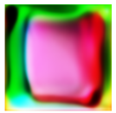 | 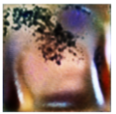 | 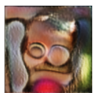 | 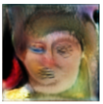

epoch: | 19th | 25th | 30th | 35th
Image: | 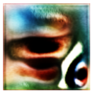 | 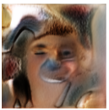 | 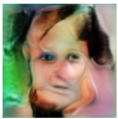 | 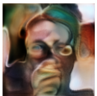

As there was an improvement, we can see that the model is inconsistent.

Final variation:

epoch: | 1st | 10th | 20th | 30th
Image: | 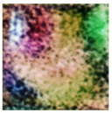 | 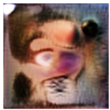 | 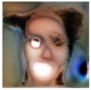 | 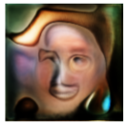

epoch: | 40th | 50th | 60th | 70th
Image: | 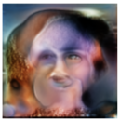 | 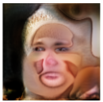 | 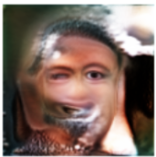 | 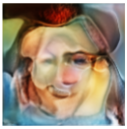

epoch: | 80th | 90th | 100th | 110th
Image: | 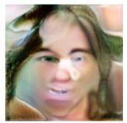 | 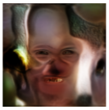 | 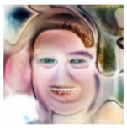 | 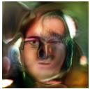

epoch: | 116th
Image: | 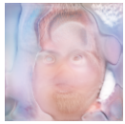

We can see better results than the first variation.
Furthermore, we can see that the model became quite consistent with creating eyes, nose and mouth – but still it is far from being recognizable as human face.

Some of the paper's results:


Loss Evaluation:

Besides the eye test, we remember that when GAN gets "better", the generator starts to "mess" with the discriminator.
Meaning, the generator becomes better as the discriminator becomes worse.
To visualize that, we will show a graph that will illustrate how D_loss and G_loss "interact" with each other:
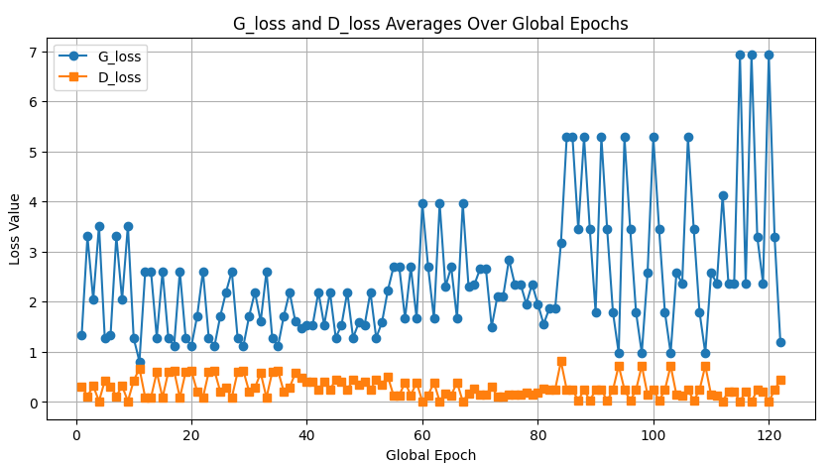

Although the Generator is still very inconsistent, we can see some positive learning.
Throughout the first ~40 epochs, the discriminator stabilizes, and so does the generator.
Then, we can see that even though the generator gets better, the discriminator gets consistent because it has already learned and is now a good model.

Eventually around 90+, although the impact is not very clear in the images we showed earlier, we can the that the generator "controls" the discriminator.
Lower loss in the generator means higher loss for the discriminator!
This means that the generator gets a lot better at "beating" the discriminator.
This is a good indication that we are on the right track, and continuous training should get us the results we are looking for.

Discussion:

This project was very beneficial for us as implementing StyleGAN deepened our understanding deep learning, particularly in the field of GANs.
We learned a lot on different levels:

The hands-on practice made us code a lot and debug even more. Specifically in our project due to the computational difficulties, making sure that there are NO mistakes helped us to learn a lot about correct deep learning coding – including making sure that we save everything using checkpoint (we saved models, losses, global parameters and even images!).
The project itself made sure that we understood the concept of GANs to the maximum, as we had to know what every single part of the training does to allow ourselves to write the best code possible.
We practiced with progressive GANs and we were able to modify small parts which showcased how far deep we got into this specific architecture.

Some of the insights we gained besides the technical ones are the importance of handling each part correctly (from controlling the resolution to choosing where the noise is being injected) to get improvements in existing methods.

As for the challenges we faced - we discussed most of them in the limitations.
We would still add the difficulty of understanding an academic paper deeply. Although the paper is written in a quite friendly way, it was very hard for us to indicate how exactly the implementation happened – and what are the important and redundant parts of the article.
To our rescue came he popularity of this paper – as there were a lot of StyleGAN tutorials on YouTube :)

Suggestions for the Future:

As of 2025, StyleGAN itself is not relevant. Until 2023 we got StyleGAN2 and StyleGAN3, alongside a lot of papers utilizing and improving it.
And of course, we also have Diffusion models that took a big part of image generation these days. That means that there are not a lot of further improvements that we can provide to the paper.
On the other hand, there are some improvements that we could me in the project, to get better results.

First, we thought about changing the number of channels used for large resolutions. We set the number of channels to a minimum of 32, as described in the paper, but we didn’t consider the fact that we reduced the resolution significantly (from 1024 to 128). Therefore, we might consider reducing the channels as we increase the resolution to a smaller minimum.

Another improvement we think might help is to increase the batch size or in general try different hyperparameters, but because of our computer resources, we couldn’t test it (yet).

